- What is Data Structure? Give the classification of data structure.
Data structure is the way of organizing the data along with the relationship among the data. The study of data structure includes
Data Structures is defined as the way of organizing all data items that consider not only the elements stored but also stores the relationship between the elements
- Defining the operations that can be performed on that data.
- Representing the data in the memory.
- Determining the amount of memory required to store the structure and the amount of time needed to process the structure.
Basically data structure is of two types:
1. Primitive data structure.
2. Non primitive data structure.
Further they are divided in to different categories
- Primitive data structure: It's a basic data structure and it's directly operated upon the machine instructions. These structures have different representation on different computers. Primitive data structure includes: Integers, floating numbers, character constants,
string constants, pointers etc.
INTEGERS:
The quantity representating objects that are discrete in nature can be represented by an integer.
For example: 2, 4, 6, 0, -23,-56 etc. are integers but 2.5, -34.56 are not integers.
FLOAT:
Float is a simple data type which takes 4 bytes in memory and we can assign decimal number in to it.
For example: 2.5, 245.67 etc.
CHRACTERS:
Characters are the literal representation of some elements selected from alphabets and characters are defined in the single quotes. There are wide varieties of character sets. Two widely used character sets are represented by
EDBIC and ASCII.
For example: '*', 'r', 'A', '2' etc. are constants.
POINTERS:
Pointers is a reference to the data structure and a simple type of variable which store the address of the another variable. Pointer is a single fixed size data item.
For example:
Int x;
Int *p;
P=&x;
Here x is the integer, where p is a pointer of integer type and pointer p points to x.

- Non primitive data structure:
It is a more sophisticated data structure emphasizing on structuring of a group of homogeneous (same type) or heterogeneous (different type) data items. Array, Linked List, Stack, Queue, Trees and Graphs fall in this category.
Non primitive data structure are further classified into following two categories
- Linear Data structure :-
“Linear data structures are data structures having a linear relationship between its adjacent elements”.
“A data structure is said to be linear if its elements form a sequence or a linear list”.
In linear data structure the elements are stored in sequential order. The linear data structures are
- Array: Array is a collection of data of same data type stored in consecutive memory location and is referred by common name.
“An array is a group of related data items that share a common name”.
This data structure is useful in maintaining table and queue in several
applications. Some common examples are,
An array for storing the rainfall of 365 days of a year,
An array of scores of a set of team,
A symbol table, etc…
We can define an array name salary to present a set of salaries of a group of employees. Writing a number called index number or subscript in brackets after the array name indicates a particular value. For example,
Salary [10];
- Linked list: Linked list is a collection of data of same data type but the data items need not be stored in consecutive memory locations.
Linked list consists of a series of structures, which are not necessarily adjacent in memory. Each structure contains the element and a pointer to a structure containing its successor. We call this theNext Pointer. The last cell’sNext pointer points to NULL.
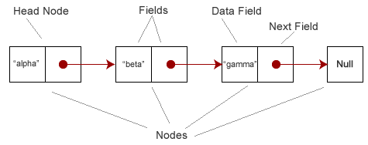
Linked list is a linear collection of elements. Each element is called node. Each node is divided into data and link field.

- Stack: A stack is a Last-In-First-Out linear data structure in which insertion and deletion takes place at only one end called the top of the stack.
This is the most useful application of array. It permits insertion and deletion of element from only one end defined as stack. The end is called the top of the stack. We can access element in opposite order from that in which we were added . this phenomenon is referred as LIFO. It is very useful in the prefix, postfix and infix expression.
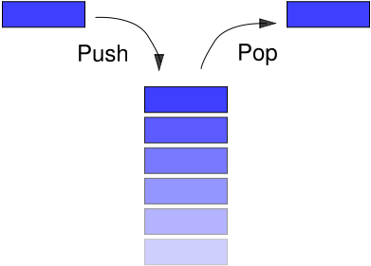

STACK
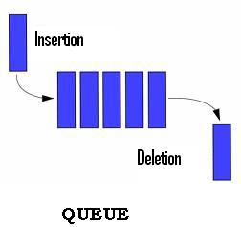
- Queue: A Queue is a First in First-Out Linear data structure in which insertions takes place one end called the rear and the deletions takes place at one end called the Front.

- Non Linear Data structure :-
Non-linear data structures are data structures that don’t have a linear relationship between its adjacent elements but have a hierarchical relationship between the elements. The following are some of the Non-Linear data structure.

  - Trees: Trees are used to represent data that has some hierarchical relationship among the data elements.
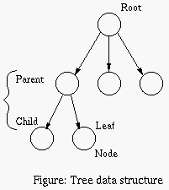
A tree is a collection of nodes. The collection can be empty; therwise, a tree consists of a distinguished node r, called the root, and zero or more nonempty (sub) trees.

  - Graphs
A graph is a non-linear data structure that represents less relationship between its adjacent elements. There is no hierarchical relationship between the adjacent elements in case of graphs.
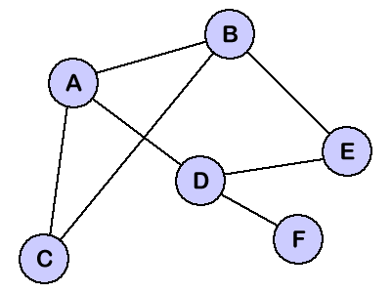

GRAPH

